
CENTRAL WEST EDUCATION DIVISION
2026 MALAWI SCHOOL CERTIFICATE OF EDUCATION
MOCK EXAMINATIONS
MATHEMATICS
PAPER II
Thursday, 26th March (100 Marks) Subject Number: M131/II
Time Allowed: 2 hrs. 30 min 08:00 - 10:30 am
INSTRUCTIONS
Questions  Answered | Tick if  Answered | Do not write in this column
1
2
3
4
5
6
7
8
9
10
11
12
Total
- This paper has 16 pages. Please check.
- The maximum number of marks for each answer is indicated against each question.
- Write your answers in the spaces provided
- Calculators may be used and all working should be clearly shown.
- Please make sure that you write your CANDIDATE NUMBER and SCHOOL on top of all pages in this paper before you start answering questions.

Section A (60 marks)
- a. Simplify $\frac{x^{2}+x-2}{{(x-1)}^{2}}÷\frac{x^{2}+2x}{xy-y}$ (4 marks)

b. The irrational $\frac{8-3\sqrt{2}}{4+3\sqrt{2}}$ is simplified to give the form $+b\sqrt{2}$ . Given that $a$ and $b$ are integers,
find the value of $a$ and $b$. (5 marks)

- a. Given that points A (a, -2a), B (2a, -3a) and C (μa, -7a) are collinear, find the value of μ. (5 marks)

b. Solve the equation $\log_{3}\left(4x+1\right)=1+2\log_{3}{2x}$ (5 marks)

- a. The sum of the first consecutive increasing terms of an AP is 6. If the product of the
three terms is – 64, find the terms. (6 marks)

b. Figure 1 shows a Venn diagram of 20 students in a class.
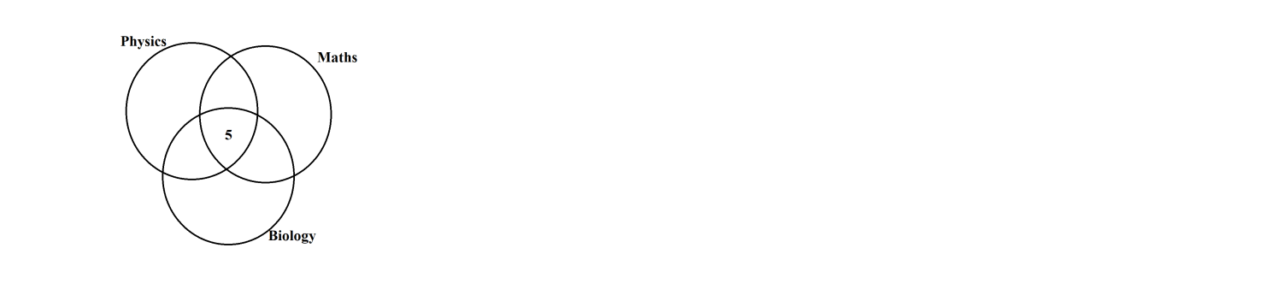

Figure 1
- 12 students study physics and maths
- 9 students study biology
- 5 students study all three subjects
- 7 students study physics but do not study biology
- 1 biologist studies maths but not physics
If everyone in a class study at least one of the subjects
- Complete the Venn diagram. (2 marks)

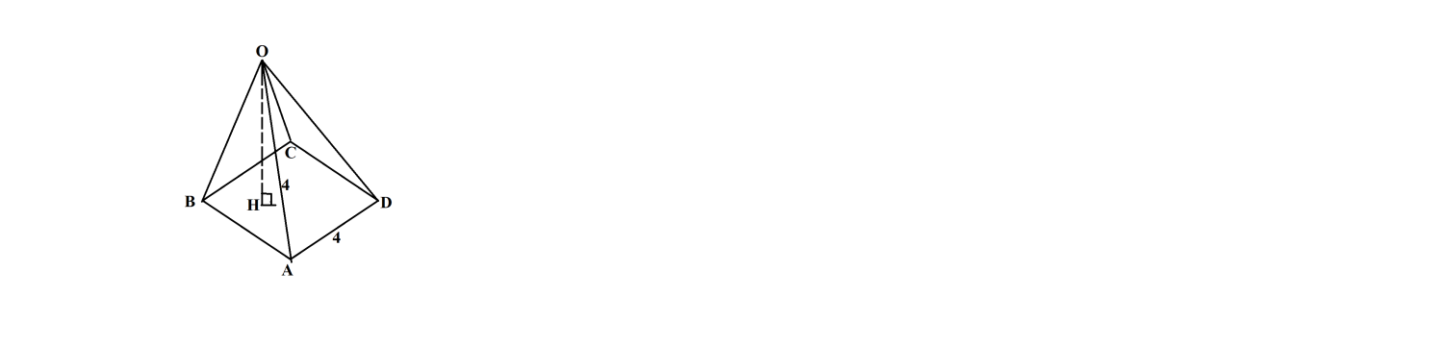
- a. Figure 2 shows half of an octahedral with side 4 cm.

Figure 2
If OH is the vertex, calculate
- Length of AC leaving your answer in surd form. (5 marks)

- Angle between line OA and the base ABCD. (3 marks)

b. Given that the polynomial $f\left(x\right)=x^{3}-3x+t$ has a factor of$(x+2)$, factorise $f(x)$. (6 marks)

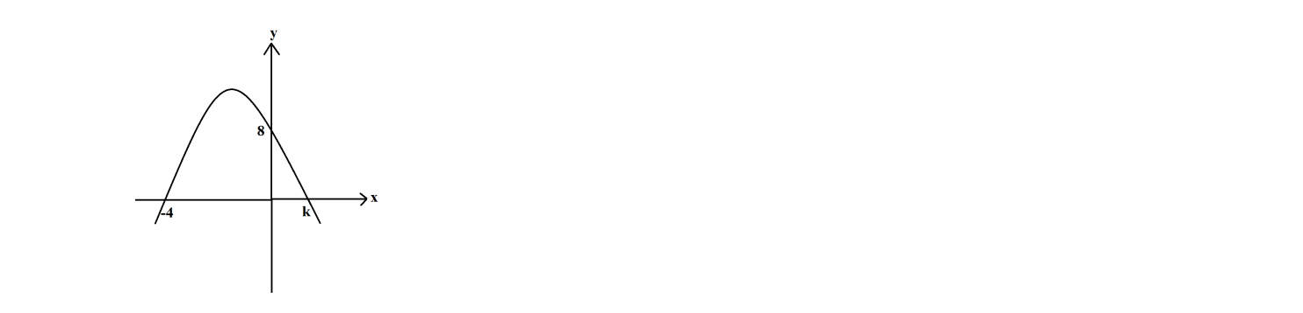
- a. Figure 3 shows a quadratic graph that cut the x – axis at – 4 and K and y – axis at 8.

Figure 3
If the graph is symmetrical at x = -1, formulate the quadratic function. (5 marks)

b. Table 1 shows heights of some pieces of metal.
Heights | 51 – 55 | 56 – 60 | 61 – 65 | 66 – 70 | 71 – 75 | 76 – 80
Frequency | 3 | 6 | 10 | 1 | 7 | 4

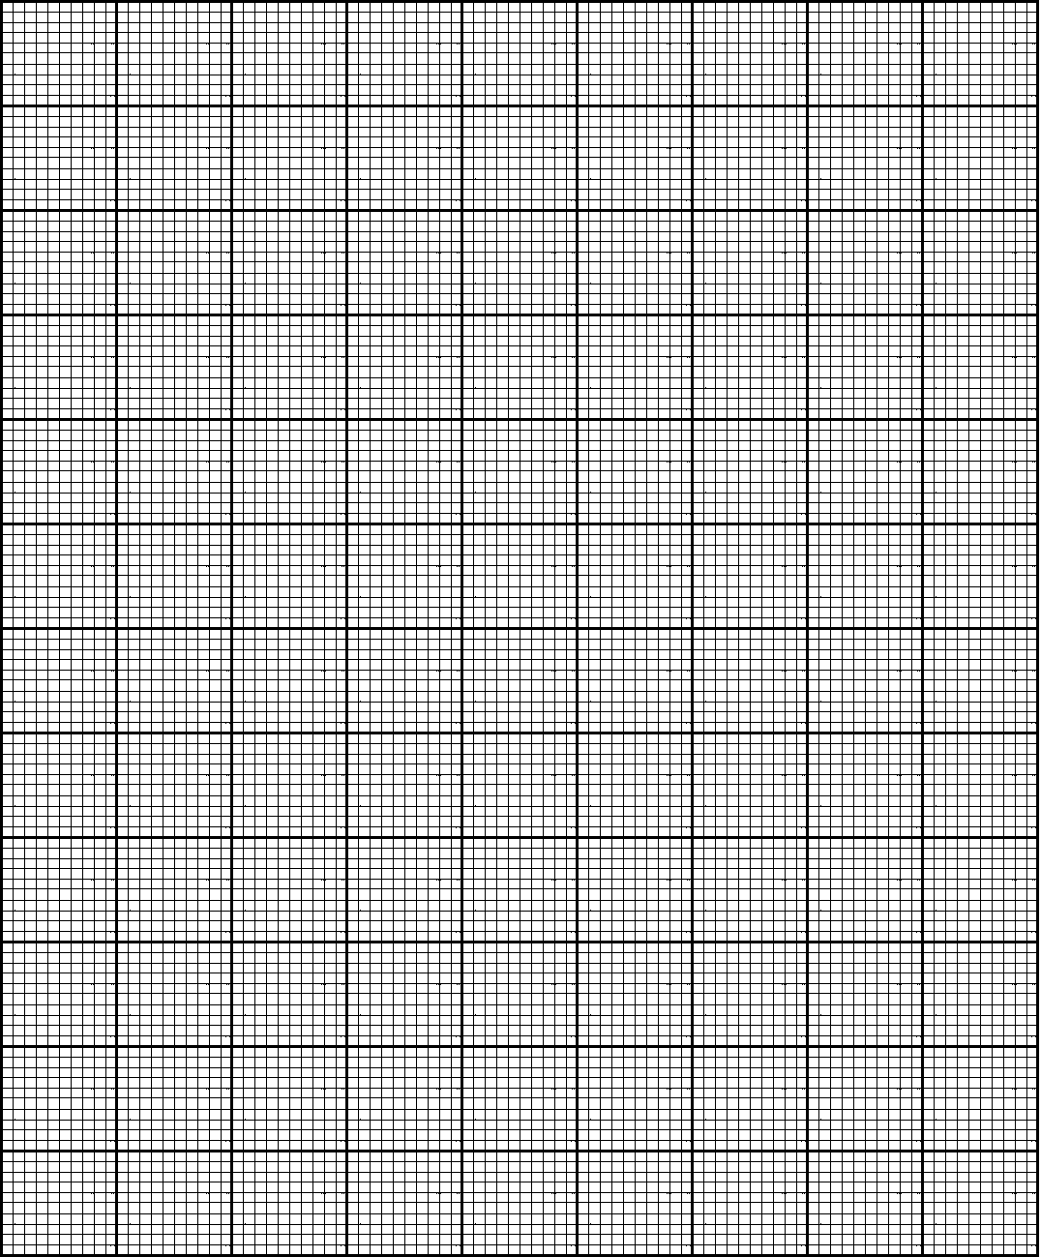
Present this information in a histogram. (4 marks)

- a. Figure 5 shows a circle ABC center O. BD and CE are tangents to the circle and ACD is a straight line.
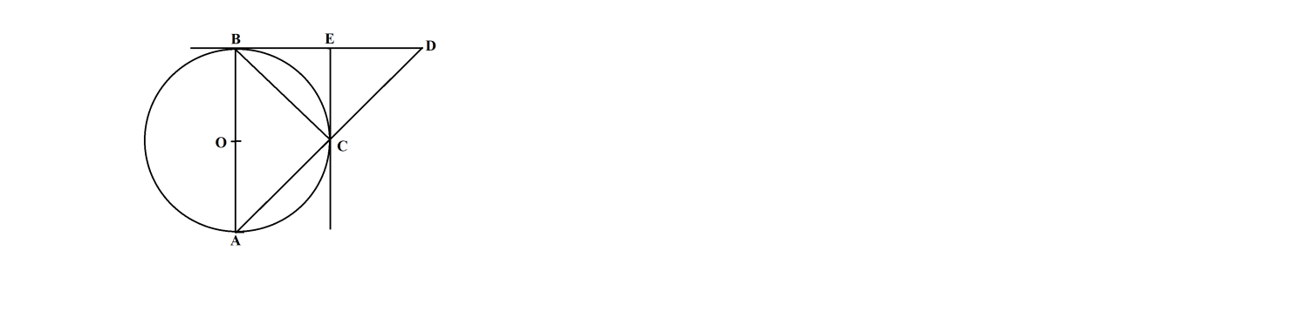

Figure 5
If AB is the diameter of the circle, prove that angle ABC = angle ECD. (5 marks)

b. Using a ruler and a pair of compasses only, construct in the same diagram:
- a circle of diameter 60 mm.
- a tangency from P, 70 mm from O, to meet the circle at X.
- mark a point R on the tangent, 20 mm from P.
- measure and state angle ORP. (5 marks)

Section B (40 marks)
Answer any four questions from this section in the spaces provided.
- The cost of spending the holiday is divided in two categories. One is partly constant K and the other varies jointly as the number of days D and number of people P in a party. The cost for 5 people in 10 days is K 129,000 and the total cost for 6 people in 14 days is K 146,000. Calculate the total cost for 8 people in 15 days. (10 marks)

- Table 3 shows values of x and y satisfying the equation $y=x^{3}-4x+1$.
X | -3 | - 2 | - 1 | 0 | 1 | 2 | 3
Y | - 14 | 1 | 4 | 1 |  | 1 | 16
- Complete the table by filling in the missing values. (1 mark)
- Using a scale of 2 cm to represent 1 unit on the horizontal axis and 2 cm to represent 5 units on the vertical axis, draw the graph of $y=x^{3}-4x+1$. (5 marks)

- Use your graph to solve equation $x^{3}-7x+1=0$ (4 marks)
- In figure 6 $\vec{OA}=\underline{a}$ and $=\underline{b}$ . M is the midpoint of OA and P lies on AB such that $\vec{AP}=\frac{2}{3}\vec{AB}$. X lies on OB produced such that OB = BX. (10 marks)
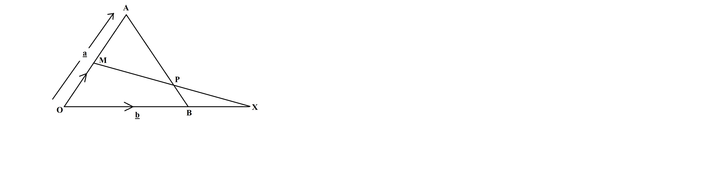

Figure 6
- Express $\vec{MA} and \vec{MP} in terms of \underline{a} and \underline{b}$ (7 marks)
- Show that M, P and X are collinear. (3 marks)

- A port A is on bearing of 190º from Q at a distance of 16 m. B is on a bearing of 310º from A. If B is 8.33 m from Q, calculate the distance of B from A correct to the nearest meters. (10 marks)

- A school team can either win, lose or draw a football match. The probabilities of winning and drawing are 0,25 and 0.4 respectively, if a team plays two games.
- Draw a probability tree diagram to show the possible results. (5 marks)

- Use the tree diagram to find the probability that a school team wins exactly one game. (5 marks)

- A theatre has a seating capacity of 250 people. The charges are K10,000 for ordinary seats and K16,000 for special seats. A minimum of K1,600,000 is required to stage a show and a theatre must make profits. There should be at most 200 ordinary seats and at least 50 ordinary seats. The number of ordinary seats is at least half the number of special seats.
- If x represents the number of ordinary seats and y represent the number of special seats, write down four inequalities that satisfy the information above in addition to $x≥50$ (3 marks)
- Using a scale of 2 cm to represent 50 units on both axes, draw the graph on the graph paper provided on page _____ to show the region represented by the inequalities. Shade the unwanted region. (4 marks)
- If 140 special seats were bought, find the maximum income the theatre can generate at maximum capacity. (3 marks)


kkkk

END OF QUESTION PAPER

